Name______________________________

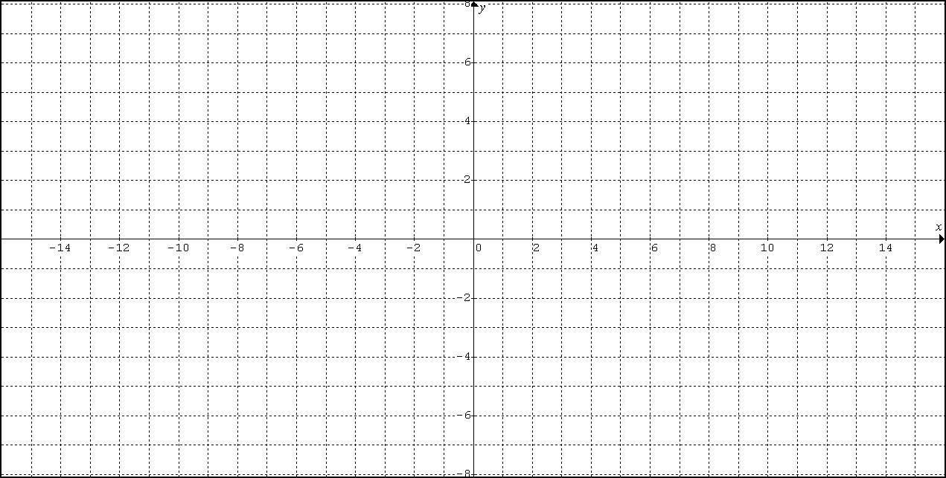
1) $f(x)=\frac{3x^{2}−\text{12}}{x^{2}−3x}$

y-intercept:______ x-intercept:______

Vertical asymptote(s):_______________

As$x→∞$, $f(x)→$______

As$x→−∞$, $f(x)→$______

Horizontal asymptote(s):_______________
(or Slant)

2) $f(x)=\frac{(2x^{2}−3x)}{(x−2)}$

y-intercept:______ x-intercept:______

Vertical asymptote(s):_______________

As$x→∞$, $f(x)→$______

As$x→−∞$, $f(x)→$______

Horizontal asymptote(s):_______________
(or Slant)

3) $f(x)=\frac{(x^{2}−9)}{(x−2)}$
y-intercept:______ x-intercept:______

Vertical asymptote(s):_______________

As$x→∞$, $f(x)→$______

As$x→−∞$, $f(x)→$______

Horizontal asymptote(s):_______________
(or Slant)

4) $f(x)=\frac{(x^{2}+x−2)}{(x^{2}+x−6)}$

y-intercept:______ x-intercept:______

Vertical asymptote(s):_______________

As$x→∞$, $f(x)→$______

As$x→−∞$, $f(x)→$______

Horizontal asymptote(s):_______________
(or Slant)

5) $f(x)=\frac{(x^{3}−1)}{(x^{2})}$

y-intercept:______ x-intercept:______

Vertical asymptote(s):_______________

As$x→∞$, $f(x)→$______

As$x→−∞$, $f(x)→$______

Horizontal asymptote(s):_______________
(or Slant)

